**Time Series Modelling and Forecasting Approach for Energy Price and Consumption Prediction**

Dr.Lilly Sheeba1 ,G.V.Sai Varun1 ,M.Sathvik2 ,K.Yashwanth Kumar3

SRM Institute of Science and Technology, Chennai.

**ABSTRACT**

***Accurate electricity charge prediction is one of the maximum essential components of choice making for power marketplace contributors to make affordable competing strategies. Prediction of electricity charge and intake is an essential venture in electricity conservation. Due to aid vector regression has desirable overall performance in coping with non-linear statistics regression trouble, in current years it regularly become used to expect constructing electricity charge and intake. Based at the ancient statistics we finish the connection among lights electricity charge and intake and its influencing elements is non-linear. The prediction of electricity charge and intake is an essential venture for electricity buying and selling companies. The prediction have to be as correct as feasible because the accuracy of the prediction interprets without delay into company's profit. Electrical masses and electricity charge and intake forecasting is one of the maximum essential venture in electricity device operation and planning. However, in a few instances we want to resolve this trouble in the absence of dependable and ok ancient statistics. To broaden correct prediction version of lights electricity charge and intake, the aid vector regression with radial foundation feature become applied. The forecast effects suggest that the prediction accuracy of aid vector regression is better than neural networks. The prediction version can forecast the constructing hourly electricity charge and intake and verify the effect of workplace constructing electricity control plans.***

**Keywords:** Prediction ,Neural Networks ,LSTM.

1. INTRODUCTION

Over the remaining 3 decades, correct modeling and forecasting of strength charges has grow to be a key difficulty in aggressive strength markets. As strength charge collection typically show off numerous complicated features, which include excessive volatility, seasonality, calendar effect, non-stationarity, non-linearity and suggest reversion, charge forecasting isn't a trivial task. However, individuals of strength marketplace want charge forecast to make selections of their each day pastime withinside the marketplace, which include trading, chance control or destiny planning. In this look at we recollect linear and nonlinear fashions for one-day-beforehand forecast of strength charges the use of additives estimation techniques. This method calls for to filter the structural, deterministic additives from the authentic time collection and to version the residual element through a few stochastic process. The very last forecast is received by means of combining the predictions of each those additives. In this paintings, linear and non-linear fashions are carried out to each, deterministic and stochastic, additives. In the case of stochastic element, AutoRegressive, Nonparametric AutoRegressive, Functional AutoRegressive, and Nonparametric Functional AutoRegressive had been considered. Furthermore, nave benchmarks are carried out at once to the charge time collection and their outcomes are in comparison with our proposed fashions. An software of the proposed technique is provided for the Italian strength marketplace (IPEX). Our evaluation shows that, in phrases of Mean Absolute Error, Mean Absolute Percentage Error, and Pearson correlation coefficient, excellent outcomes are received whilst deterministic element is predicted by means of the use of parametric method. Further, Functional AutoRegressive version plays rather higher than the relaxation at the same time as Nonparametric AutoRegressive is distinctly aggressive. The essential purpose of this paintings is to version and forecast strength charge time collection. To this end, a additives estimation technique is used wherein the charge time collection is split into essential additives: deterministic and stochastic. The deterministic element includes long-run dynamics, mul- tiple periodicities (every year and weekly cycles) and calendar consequences while the stochastic element money owed for the short-run dynamics of the process.

II. RELATED WORKS

[1]Electricity Price Forecasting for Operational Scheduling of Behind-the-Meter Storage Systems.In this paper, a forecasting method is proposed to pro- vide correct rate forecasts for operation of behind-the- meter garage systems. This method consists of separate forecasting fashions to take gain of excessive-decision marketplace statistics at the side of hourly statistics so one can seize rate spikes as an awful lot as possible. The proposed inta-hour rolling horizon framework is carried out to replace the forecasts on an hourly basis. From statistical analysis, the proposed method outcomes in 20% development in forecast accuracy in comparison to to be had PDPs, and has a excessive functionality of detecting rate spikes

1. Day-Ahead Electricity Price Forecasting and Scheduling of Energy Storage in LMP Market.This paper proposes associate degree improvement strategy for the day-ahead coming up with of utility in hand energy storage operation whereas considering the electricity worth volatility in locational marginal rating (LMP) market. The planned optimization strategy works upon the expected day-ahead electricity costs while considering the results of energy storage programing on consequent days electricity prices. during this study, a piecewise linear relation between load and LMP is established mistreatment historical load and LMP data. The piecewise linear relation results are provided to the next stage for the proposed energy storage optimization that is resolved using Quadratic Programming.

[3]Electricity Prices Forecasting using Artifificial Neural Networks.This paper gives the outcomes of the usage of schooling algorithms for recurrent neural networks primarily based totally at the prolonged Kalman clear out out and its use in electric powered power charge prediction, for each cases: one-step in advance and n-step in advance. In addition, it's miles covered the stableness evidence the usage of the famous Lyapunov methodology, for the proposed synthetic neural community skilled with an set of rules primarily based totally at the prolonged Kalman clear out out. Finally, the applicability of the proposed prediction scheme is proven via way of means of suggest of the one-step in advance and n-step in advance prediction the usage of information from the European electricity system.

1. Hydro-Optimization-Based Medium-Term Price Forecasting Considering Demand and Supply uncertainty.In this have a look at, an energy marketplace version thinking about deliver and call for dynamics, and representing TEM below precise situations is shaped for medium-time period forecasting activities. Transactions on Power Systems Hourly charge forecasting for every year charge averages is done and eventualities for deliver and call for facet are covered such that charge degrees are acquired in place of unmarried factor forecasts. For this purpose, three most important additives and a sub element of energy marketplace version are developed, which might be energy call for, deliver, charge forecasting fashions and hydro optimization sub-version. This have a look at has a completely unique shape thinking about that it makes use of all of those fashions withinside the identical simulation.

[5]Short-Term Forecasting of Electricity Spot Prices Containing Random Spikes Using a Time-Varying Autoregressive Model Combined With Kernel Regression.In this paper, a hybrid version is constructed to forecast power rate with the attention of each regular rate versions and rate spikes. While regular rate can correctly be forecasted the use of ARXTV version, it can't song the rate spikes correctly. This quandary has been conquer i n the the ARXTV with kernel hybrid version b y combining regression.

1. Short-Term Electricity Price Forecasting via Hybrid Backtracking Search Algorithm and ANFIS Approach.This research has proposed a hybrid approach for day ahead electricity price prediction in the Ontario electricity market containing a multi-objective feature selection technique and hybrid forecast engine.
2. Forecasting Functional Time Series with a New Hilbertian ARMAX Model: Application to Electricity Price Forecasting.This paper proposes a brand new practical forecasting technique that tries to generalize the same old seasonal ARMAX time collection version to the L Hilbert space. The shape of the proposed version is a linear regression in which practical parameters perform on practical variables. The variables may be lagged values of the collection (autoregressive terms), beyond found innovations (shifting common terms), or exogenous variables.

[8]A Deep Learning Based Hybrid Framework for Day-Ahead Electricity Price Forecasting.

In this paper, a unique deep-getting to know primarily based totally hybrid framework, composed o f function preprocessing module, deep-getting to know primarily based totally factor prediction module, mistakess repayment module, and probabilistic prediction module, is supplied for forecasting day-in advance energy prices. The utilization of the primary modules is carried out to discover outliers and become aware of the correlated functions of energy rate series. The 3 deep getting to know models, DBN, LSTM RNN, and CNN withinside the 2d module, are proposed and in comparison to extract complex nonlinear functions.

III.(A) PROPOSED SYSTEM

In strength load information, now no longer only a few day by day intake profiles again and again seem however additionally a few particular mixtures of profiles arise periodically even though every consumer has very own specific profile styles and its repeating period. This proposed gadget takes benefits of day by day intake profiles of the customers and their periodical intake styles. To educate a LSTM to research the styles, the rate and intake load information is converted into a chain of pre- described profile. During the mastering process, embedding vectors, which connote the traits and relationships of the profiles, are discovered in line with the profiles appearances withinside the series. Based at the discovered embedding vectors, the LSTM acknowledges the present sample withinside the profile series and generates expected destiny intake. This gadget proposes a short-time period strength load sample forecast technique with the aid of using making use of day by day foundation intake profile sequences with a LSTM network. The profile shows that the kind of day by day strength load shapes. The streaming load information is segmented into day by day foundation, and every day rate and intake sample are converted right into a consultant profile. The LSTM takes the profile sequences for its enter in place of the minute or hour primarily based totally load information and plays a month-beforehand intake sample profile prediction. The proposed technique makes a speciality of predicting the styles current in day by day load profile sequences as opposed to predicting the burden quantity at a selected factor of time.

1. ADVANTAGES OF PROPOSED SYSTEM

Problems are solved on an end-to-end basis Achieved competitive performance on various datasets Reduces generalization error. Built-in error handling Tolerates Variations Boost the Performance.

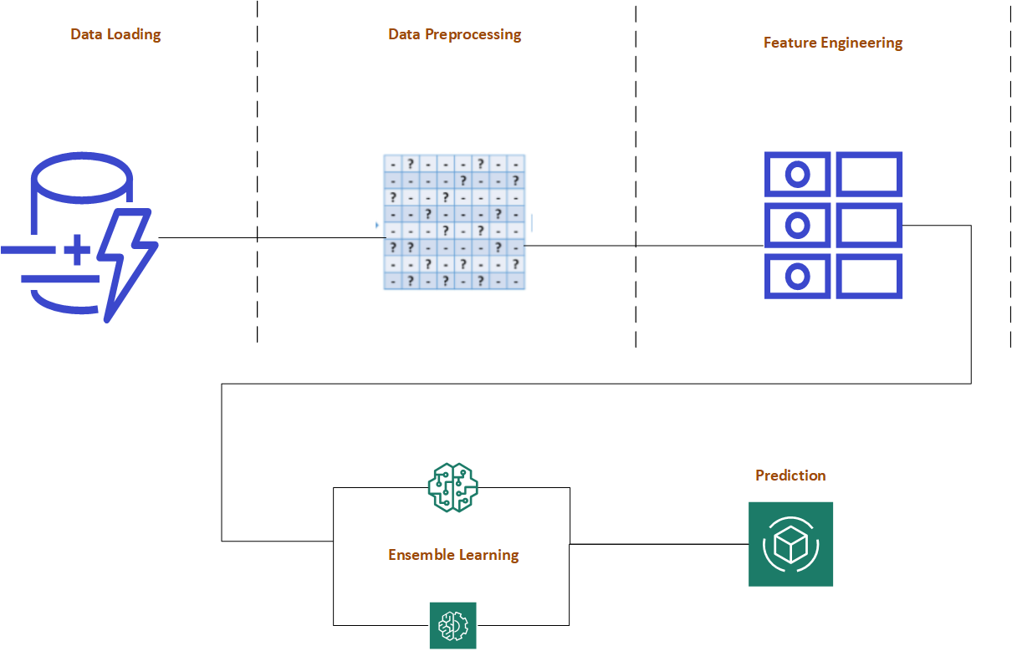

**Fig: Architecture Diagram of the proposed system.**

IV. PROPOSED ALGORITHM

Bi-Directional LSTM Algorithm.In bidirectional LSTM, instead of training a single model, we introduce two. The first model learns the sequence of the input provided, and the second model learns the reverse of that sequence.Since we do have two models trained, we need to build a mechanism to combine both. It is usually referred to as the Merge step. Merging can be one of the following functions:Sum,Multiplication,Averaging,Concatenation (default).Bidirectional LSTMs in short BiLSTM is an addition to regular LSTMs which is used to enhance the performance of the model on sequence classification problems. BiLSTMs use two LSTMs to train on sequential input. The first LSTM is used on the input sequence as it is. The second LSTM is used on a reversed representation of the input sequence. It helps in supplementing

additional context and makes our model fast.

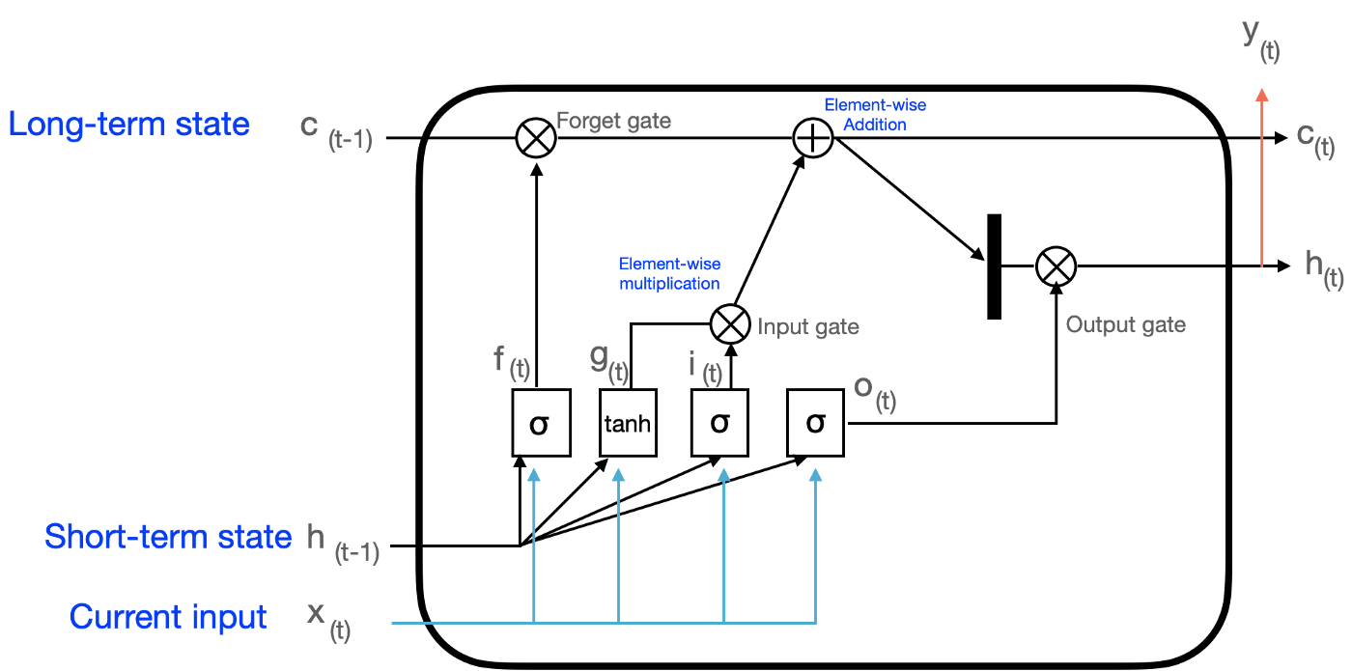

**Fig: Bi-Directional LSTM**

V. METHODOLOGY

1. Data Analysis

This Exploratory information evaluation is a information evaluation strategies to evaluation information and locate the inherent regulation primarily based totally at the real distribution of information. Exploratory Data Analysis(EDA) the usage of visible strategies to find out the shape contained withinside the information. Visual information evaluation strategies in use in a huge variety may be traced again to many centuries ago, it's far due to the fact that human eyes and brains own sturdy structural capacity to stumble on that occupy such vital function in information exploring. And visible evaluation is to play quite a few human fashions withinside the processing capability of the unique manner to show information. Analysts usually do Exploratory Data Analysis for information fist, then are sure to chose the mode of shape amount or stochastic amount; Exploratory Data Analysis can also display the sudden deviation which the not unusualplace version can not. The key factor of Exploratory Data Analysis isn't most effective bendy follow to the information shape however additionally bendy response to the found out mode of the later evaluation- step. Verification of Exploratory Data Analysis compare the found mode or effect-evoke. The Verification level include: aggregate of different closed associated information; gather and evaluation the brand new information to affirm the results.

1. Data Preprocessing

It is an critical venture and important step in Text mining, Natural Language Processing (NLP) and statistics retrieval (IR). In the region of Text Mining, records preprocessing used for extracting exciting and non- trivial and information from unstructured textual content records. Information Retrieval (IR) is largely a depend of figuring out which files in a group need to be retrieved to fulfill a customers want for statistics. The customers want for statistics is represented with the aid of using a question or profile, and includes one or extra seek phrases, plus a few extra statistics together with weight of the phrases. Hence, the retrieval selection is made with the aid of using evaluating the phrases of the question with the index phrases (critical phrases or phrases) performing withinside the record itself. The selection can be binary (retrieve/reject), or it can contain estimating the diploma of relevance that the record has to question. Unfortunately, the phrases that seem in files and in queries frequently have many structural variants. So earlier than the statistics retrieval from the files, the records preprocessing strategies are carried out at the goal records set to lessen the dimensions of the records set so as to growth the effectiveness of IR System. The important concept at the back of lemmatization is to lessen sparsity, as exceptional inflected kinds of the identical lemma may also arise infrequently (or now no longer at all) for the duration of education. However, this can come on the value of neglecting critical syntactic nuances. The that means of those multiword expressions are frequently rarely traceable from their character tokens. As a result, treating multiwords as unmarried devices may also result in higher education of a given model. Because of this, phrase embedding toolkits together with Word2vec advocate statistical methods for extracting those multiwords, or without delay consist of multiwords at the side of unmarried phrases of their pretrained embedding spaces.

1. Feature Extraction

Feature selection can be defined as a process of selecting the subset from the original feature set on the basis of importance of features. There are three categories of feature selection methods: wrappers, filters and embedded methods. Feature extraction can be defined as a process of extracting a set of new features from the features set that is generated in feature selection stage. Ambiguity Measure (AM) feature selection method will assign a higher score to the features which appear consistently in only one category. AM score is calculated for each feature. This method assigns score close to 1 if the feature is unambiguous; otherwise it assigns score close to 0. There is one threshold is given and based on this threshold, the features having AM score below that threshold that features are filtered and the features having AM score above that threshold are used for learning phase. Information gain of a feature is calculation the difference of entropy whether it appears in the text. The larger information gain, the greater contribution the characteristics to the text. Characteristics with high information gain will be selected as feature.

1. Prediction

The Long Short-Term Memory community, or LSTM community, is a recurrent neural community this is educated the usage of Backpropagation Through Time and overcomes the vanishing gradient hassle. As such, it could be used to create huge recurrent networks that during flip may be used to deal with tough series troubles in system mastering and gain contemporary results. Instead of neurons, LSTM networks have reminiscence blocks which might be related via layers. A block has additives that make it smarter than a classical neuron and a reminiscence for current sequences. A block carries gates that control the blocks kingdom and output. A block operates upon an enter series and every gate inside a block makes use of the sigmoid activation gadgets to govern whether or not they're precipitated or not, making the extrade of kingdom and addition of records flowing via the block conditional. The Long Short Term Memory neural community is a sort of a Recurrent Neural Network (RNN). RNNs use preceding time occasions to tell the later ones. For example, to categorise what type of occasion is going on in a movie, the version wishes to apply records approximately preceding occasions. RNNs paintings nicely if the hassle calls for best current records to carry out the prevailing task. If the hassle calls for long time dependencies, RNN could battle to version it. The LSTM changed into designed to research long time dependencies. It recalls the records for lengthy periods.

1. RESULTS

Our proposed LSTM model which has 95% percentage accurate output ,which is totally contrast from existing system which is a kind of failure with 73% accuracy rate.Although it may take several iterations to get result precisely.Using LSTM i.e., Long Short Term Memory Algorithm is debut for this project from machine learning.The drawback may consists of requirement of loads of data for the machine to learn which also will take two or more iterations.

1. IMPLEMENTATION

Persistence forecast considers that future values of the

time series can be calculated on the assumption that the condi

tions remain unchanged between “current” time *t* and future

time *t* + Δ*t*. A straightforward implementation of the persis

tence model is simply as follows:

*y*ˆ*t*+Δ*t* = *yt.*

Also, the corresponding RMSE, i.e., root mean square error,

can be calculated as follows:

*yt − yt*]2

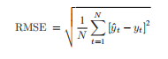

where *y*ˆ*t* and *yt* are the forecast and the real value at time point

*t*, respectively; *N* is the size of the samples.

1. FUTURE WORK

Furthermore, for the destiny paintings we are able to attempt to carry out the version with the usage of the specific form of dataset. Different information evaluation is wanted for specific sort of customer (ex: home, public facility, etc.). For the equal case, we are able to cognizance to enhance the overall performance of the version to offer the higher experimental bring about the destiny.

VI. CONCLUSION

The proposed LSTM-primarily based totally version is skilled and examined on a benchmark dataset which contained energy intake statistics for exclusive types of homes in America with one-hour resolution. In order to assess the proposed version relatively, MLP, RF, and SVM also are created and examined at the identical dataset. The week-in advance forecasting effects had display that the proposed LSTM-primarily based totally version have been capable of forecast constructing energy intake higher than the comparative fashions in 9 of twelve months. a short-time period energy load prediction technique primarily based totally on a LSTM community is proposed. This technique makes use of sequences of every day foundation load profile, temperature, and humidity statistics as enter to create embedding vectors that connote the intrinsic traits and relationships of the profiles.

**REFERNCES**

[1]P.Mandal, A. U. Haque, J. Meng, A. K. Srivastava, and R. Martinez, "A novel hybrid approach using wavelet, rey algorithm, and fuzzy artmap for day-ahead electricity price forecasting," IEEE Transaction on Power System, vol. 28, no. 2, pp. 10411051, May 2013.

[2]Hong, P. Pinson, S. Fan, H. Zareipour, A. Troccoli, and R. J. Hyndman, "Probabilistic energy forecasting: Global energy forecasting competition 2014 and beyond," International Journal of Forecasting, vol. 32, no. 3, pp. 896913, July 2016.

[3]C. Wu, S. C. Chan, K. M. Tsui, and Y. Hou, "A new recursive dynamic factor analysis for point and interval forecast of electricity price," IEEE Transaction on Power System, vol. 28, no. 3, pp. 2352 2365, August 2013.

[4]Christensen, A. Hurn, and K. Lindsay, "Forecasting spikes in elec- tricity prices," International Journal of Forecasting, vol. 28, no. 2, pp. 400 411, June 2012.

[5]Lu, Z. Y. Dong, and X. Li, "Electricity market price spike forecast with data mining techniques," Electric Power Systems Research, vol. 73, no. 1, pp. 1929, January 2005.

[6]K. Aggarwal, L. M. Saini, and A. Kumar, "Electricity price fore- casting in deregulated markets: A review and evaluation," International Journal of Electrical Power & Energy Systems, vol. 31, no. 1, pp. 1322, January 2009.

1. H. Zareipour, C. Canizares, and K. Bhattacharya, "Economic impact of electricity market price forecasting errors: A demand-side analysis," February 2010. [8]Nasrolahpour, S. J. Kazempour, H. Zareipour, and W. D. Rosehart, "Strategic sizing of energy storage facilities in electricity markets," October 2016.
2. S. Shaee, P. Zamani-Dehkordi, H. Zareipour, and A. N. knight, "Eco- nomic assessment of a price-maker energy storage facility in the Alberta electricity market," Energy, vol. 111, pp. 537547, September 2016.
3. J. Han and M. Kamber, Data Mining: Concepts and Techniques. Morgan Kaufmann Publishers, 2006.

[11]N. M. Pindoriya, S. N. Singh, and S. K. Singh, "An adaptive wavelet neural network-based energy price forecasting in electricity markets," IEEE Transaction on Power System, vol. 23, no. 3, pp. 14231432, August 2008.

1. H. Zareipour, C. A. Canizares, K. Bhattacharya, and J. Thomson, "Appli- cation of public-domain market information to forecast ontarios whole- sale electricity prices," IEEE Transaction on Power System, vol. 21, no. 4, pp. 17071717, November 2006.
2. Turkish electricity generation and transmission statistics, www.teias.gov.tr, 2015.
3. A. Bello, D. W. Bunn, J. Reneses and A. Munoz, "Medium-term probabilistic forecasting of electricity prices: A hybrid approach," IEEE Trans. on Power Systems, vol. 32, no. 1, 2017.

[15]N. Amjady, F. Keynia, and H. Zareipour, "Wind power prediction by a new forecast engine composed of modied hybrid neural network Sustainable Energy, vol. 2, no. 3, pp. 265276, July 2011.